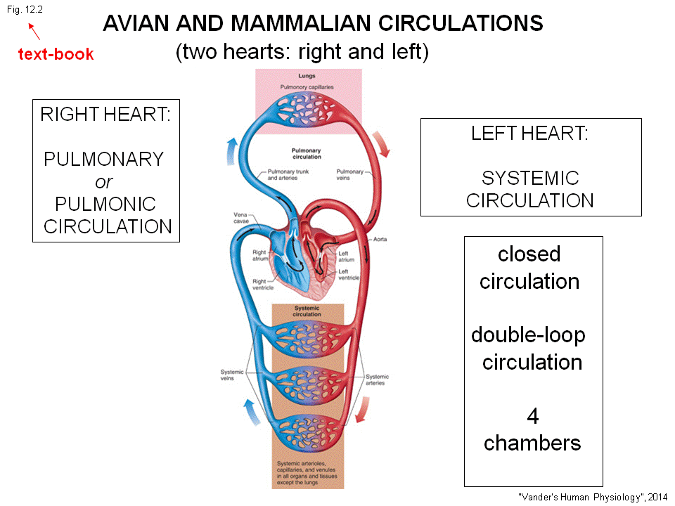
-2 loop circulation: Systemic and pulmonary circulation.
-closed circulation
-4 chambers

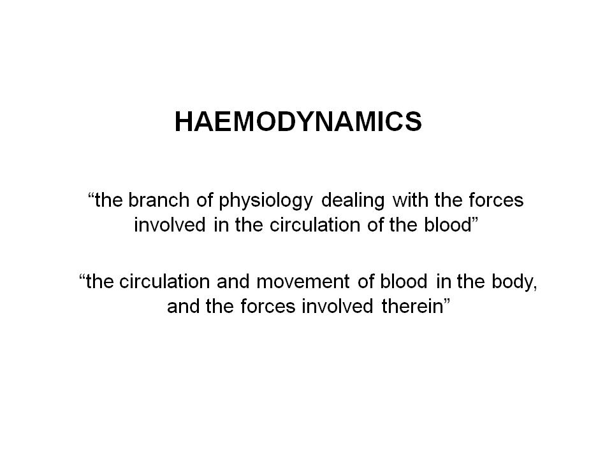
-physics involve: mass, force, speed, acceleration.
-the cardiovascular is to move stuff.

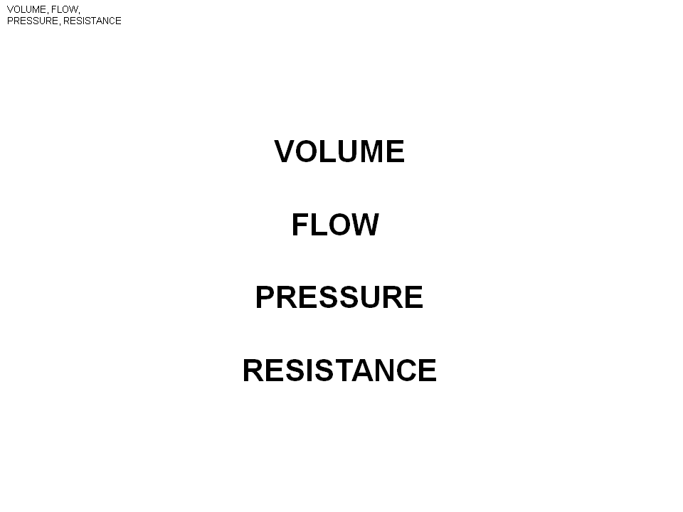
The 4 basic : Volum , flow , pressure, resistant. Look at volume first.
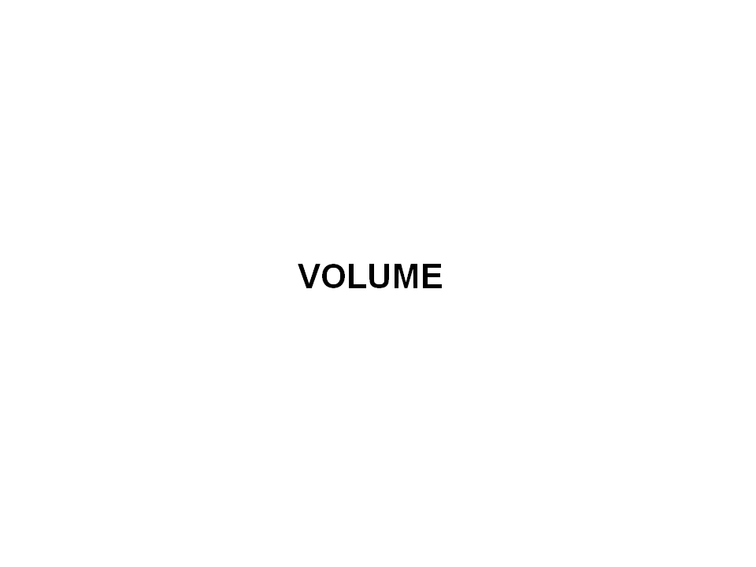

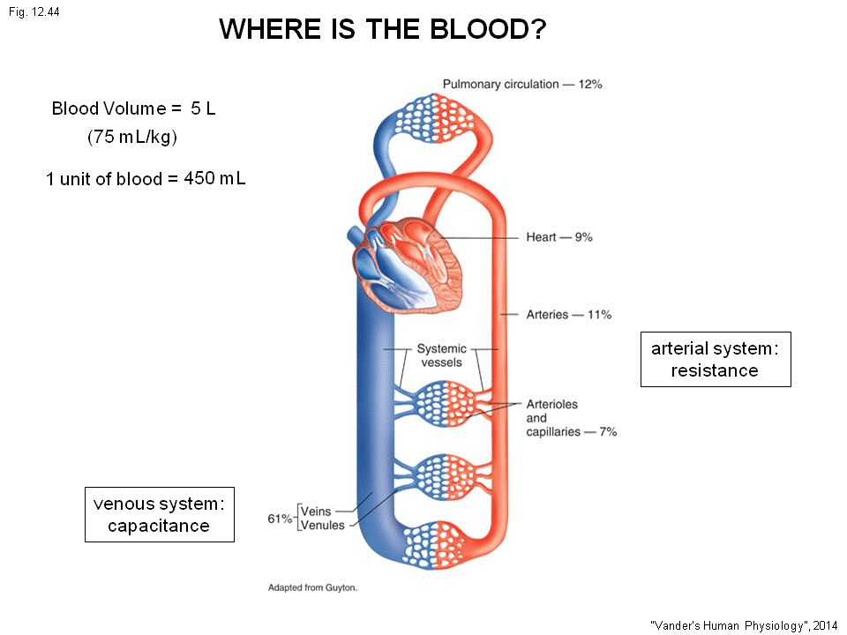
You don’t have to memorize all the numbers in this lec.

The blood volume = 5 L. (memorize) ---this is for man, healthy, around 20 , and at rest.
(women has less than 5 L of blood, due to she weight last.)
Everyone has 75ml of blood per Kg.
1 unit of blood =450ml.Most of blood (60%) is in the veins, about 10 %in artery , 10 %in heart, 10%in the big vessels, lung, pulmonary circulation, and about 10 %in arterials capillaries .
This is why we refer Veins (Venous) as capacity vessel = capacitance = this is where most of the blood is seating.
If start to exercise, things can change. But , under normal situation, 60%of blood is in the vein and venous.
The arterial system =resistant system. This is because left ventricle pump the blood to the whole body and there is a resistant to the flow (next lec), most of the resistance is in arterials and small artery.
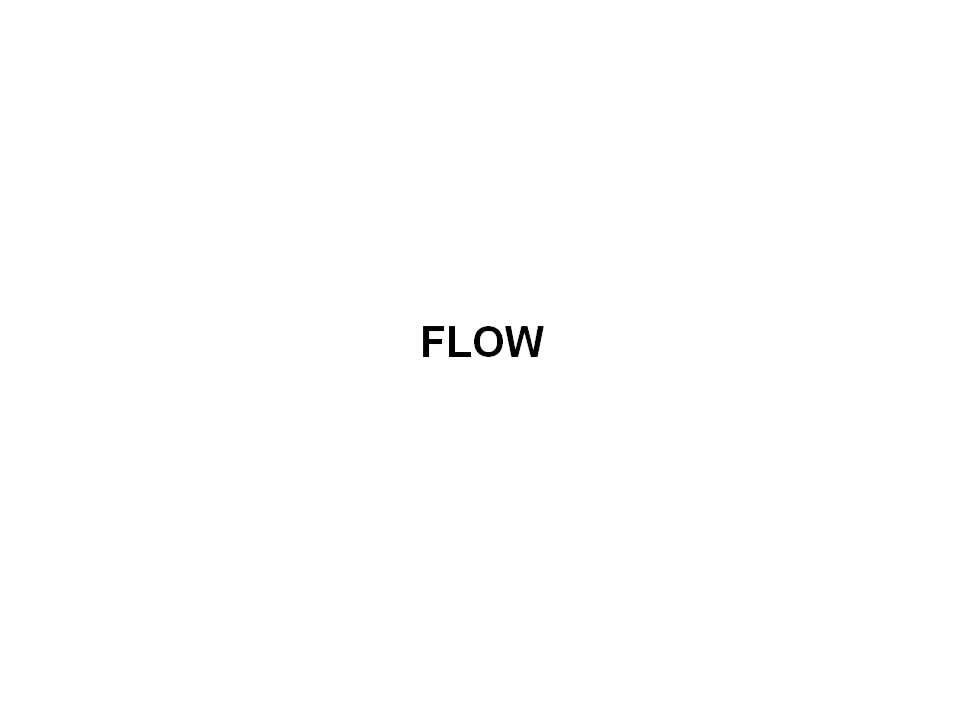

What is flow:
On the left is the left heart (left atrium and left ventricle) pump the blood to all over the body.
There is a particular flow, this flow is call =cardiac output.
Every minutes 5000ml(5L) is pumped in 1 minutes. This is the cardiac output.
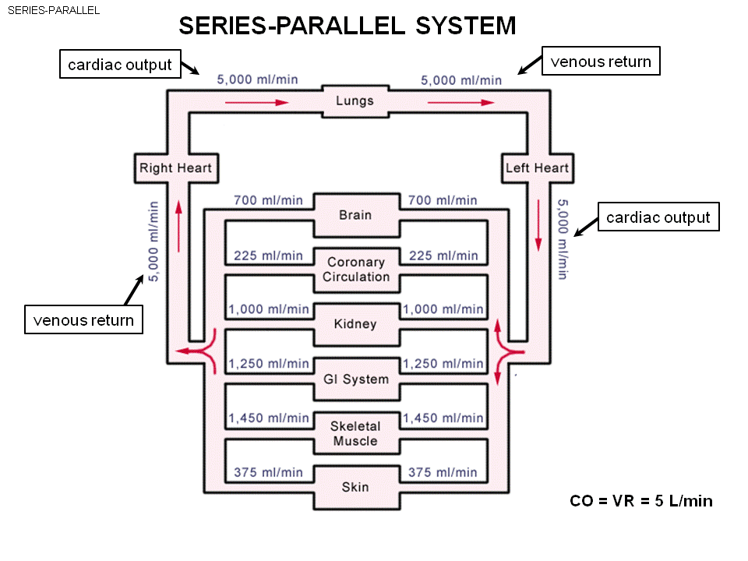
This output splits into many organs, some of the organ need a larger flow than the others. Those flow go to these organs through the big arteries and leave through big veins. Go back to right heat from the right atrium. To the right ventricle and than pump to lungs, then to left atrium.
The flow here is no leak in and out should both be 5000ml/min in and out the system. The flow in and out the lungs should both be 5000ml/min.
The flow that comes back to the left heart is called venous return. –the return of the blood to the heart in big veins. (Big veins , venous return bring blood back to left and right heart.)
On the balance, the flow through left heart == right heart.
- If the flow of right heart flow is bigger than the left heart => blood accumulate in the lungs.
- So the venous return should be larger than cardiac output. Otherwise there is accumulation in the system.

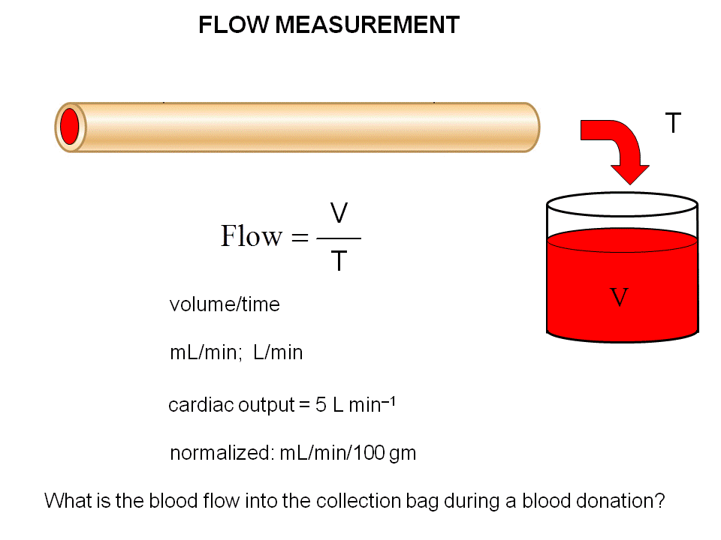
-give a isolated vessel, and pump the blood through the vessel.
-The easiest way is to put a gradual cylinder here. Let blood flow to cylinder T (time) and measure the volume of collected blood.
Ex : If collect 10ml over time 2 minutes. What is the flow : 10ml/2min = 5ml/min
The flow is the change of volume /Change of time. Flow =V/T. Flow is to measure the volume moving in time.
The unit commonly used : ml/min, L/min. ( ex: cardiac output ==5000ml/min or 5L/min.)
If you compare the flow through brain and through eyeball => One is gonna be huge another is small. Why? Because the eyeball is much smaller in size, so obviously brain has a larger flow than eyeball. need to normalize by gram.
- In that case : Ml/min/100gm
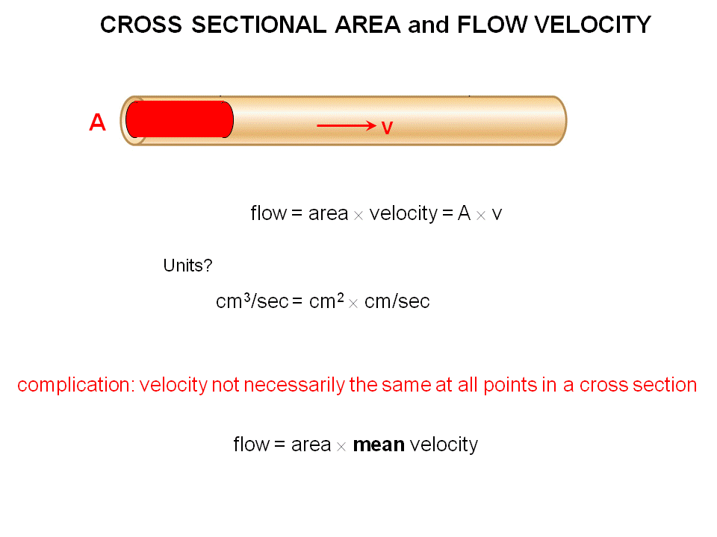
What is the flow rate for blood donation? How much blood you give, How long it take.

This way involve in cross section area and velocity.
|------d-----| the distance blood moves in 1 sec

The cross section is A, speed is V.
The flow = A*V
Think the blood in cross section move distance d.
What will be d?
Suppose the V = 1cm/sec.
The d will be 1 cm.

This is a cylinder, the volume = area * length = cm^2* cm = A(area ) *d cm
The movement of the volume ==Flow => Volume /T (the time ) ==cm^3/sec
So this is the flow rate = A*V ==cm^3/sec
- This is why the flow is simply A*V.
- You have area with high and low V, these 2(A,V) value determined the flow rate.
We assume here every blood is move at the same speed, but this is not true.
The true equation Average speed * area (cross section) =Flow

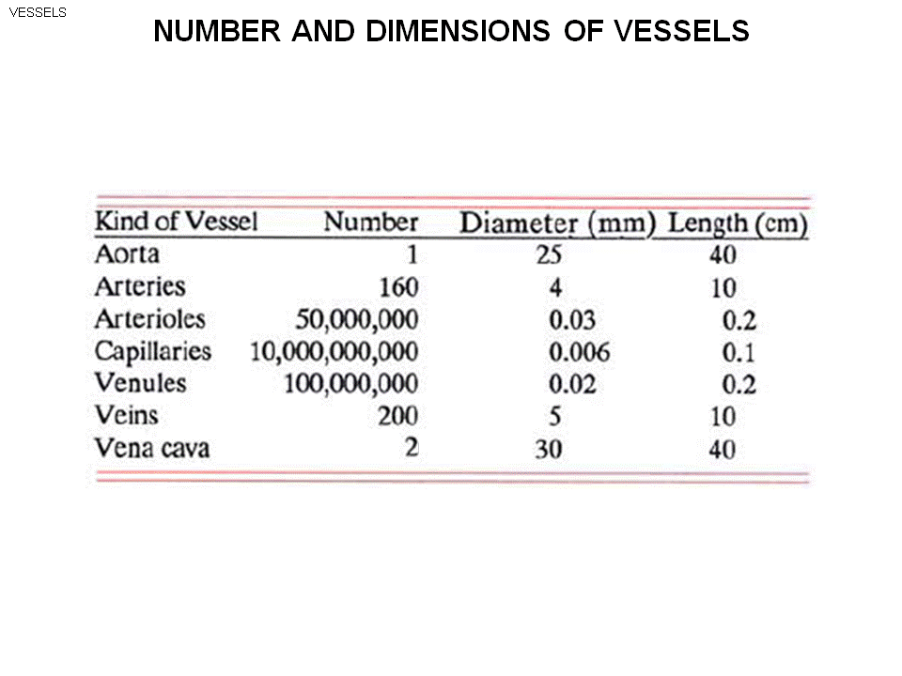
The cardiovascular is a branching structure.
Big vessel come out the left ventricle =Aorta.
Aorta Arteries (branch inside to the organs) Arterioles (each arterioles will branch into several capillaries ) capillaries (capillaries join together) venules (join)veins vena cava. (There is 2 venea cava bring blood back to right atrium.)

As this things branch they get shorter in length and area (cross section get small).
This is the vascular tree.
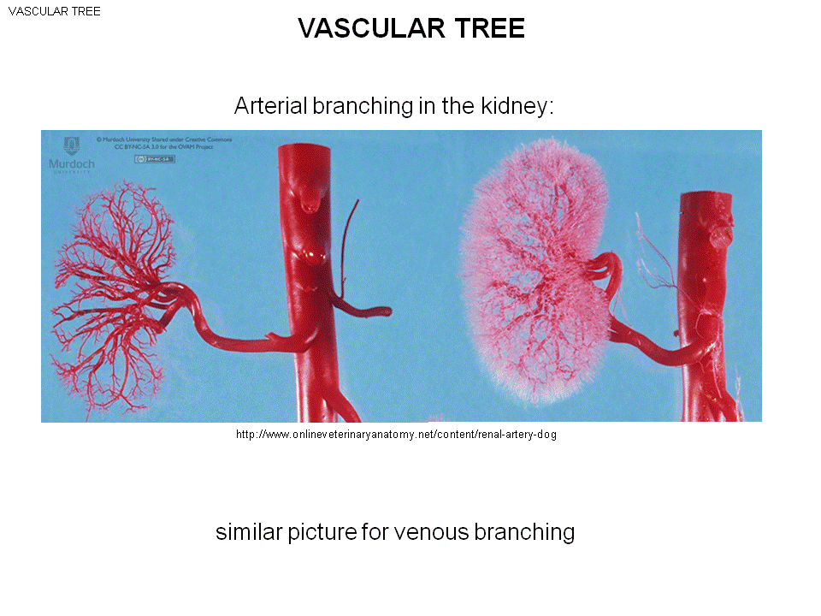
This is the renal artery
The renal artery bring the blood to kidney from the large aorta. There is also other artery on aorta to other kidneys.
aorta smaller arteries small arteriole (the further branch on kidney). Here we can see the arteriole tree.
The right is finer arterials. This is a dense structure of branching. The branching structure make the kidney is close to blood vessel.
- Fick’s law!! The highO2 can diffuse with big flux and big flow (The diffusion distance is small, high concentration difference)
- 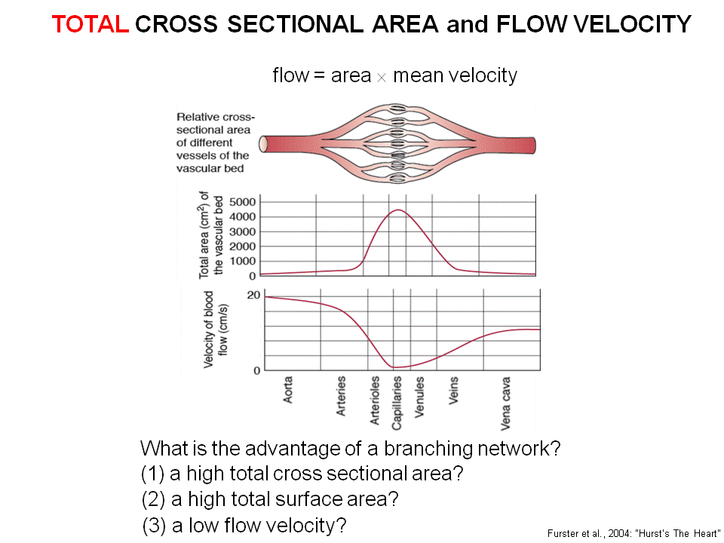
Vena cava is singular, plural is venae cavae.
The total cross section area:
- Aorta only have a few cm large.
- All the arteries coming from aorta and take cross section, add up : Bigger than aorta
- Arteries cross section : even bigger (dramatic increase )
- In capillaries , 5000 cm ^3 in total cross section in the systemic side of circulation
- Join together to vena cava , the cross section drop back down.
The flow through Aorta – cardiac output ( 5 L/min )
- Now we add up all the flows through arteries, also 5L/min
- Add up all the flows arterioles, 5 L/min
- The certain amount of mass go through one direction, it can’t disappear.
- The total flow of that branching level is exactly the same.

The flow is A *V (mean).
- The flow at any level is constant (5L/min)
- the cross section is increasing, the V is decreasing.
- In aorta, the speed is very fast in begin, than drop as we move down to smaller and smaller arteriole. At the capillary , the speed is only 0.5 ml/sec (compare to 20 ml/sec in Aorta ).
- As cross section decreases at the Venus side, the flow has to go back up.
As the structure branch: what happen to the surface area?
- The total surface area increases. (We are not talking about cross section area, but total surface area.) By the time we reaches capillaries, it’s a huge area.
- The concentration gradient of CO2 is though the wall of the vessel, from the blood to organ around it. The area in Fick’s law is the not the cress section, but the area that the stuff is moving.
- The huge surface area of the capillaries allow a big flux to keep function.
As move down to smaller to smaller vessel, the speed decrease. T
- Advantage: The residence time in capillaries (How long the capillaries stay in the lungs)
- If the residence time in capillaries is small, the RBC will not have time to exchange.
- The small speed, the long time allow the RBC to pass though slowly and unload its Oxygen anf pick up Co2.
So: The large area of the surface of the vessel , and the low speed through. Branching system will give you this .
-Think about the respiratory system, why the lung branch?
What is pressure? Applying a force on the area . (Force /area )

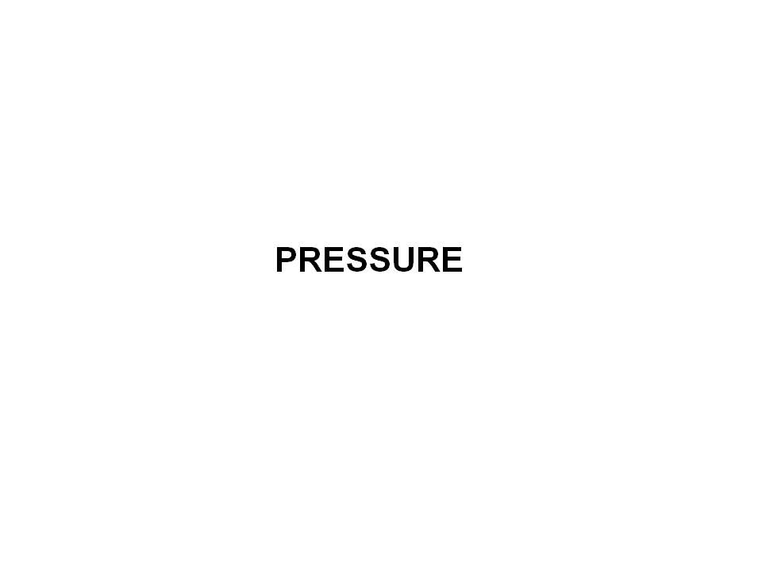
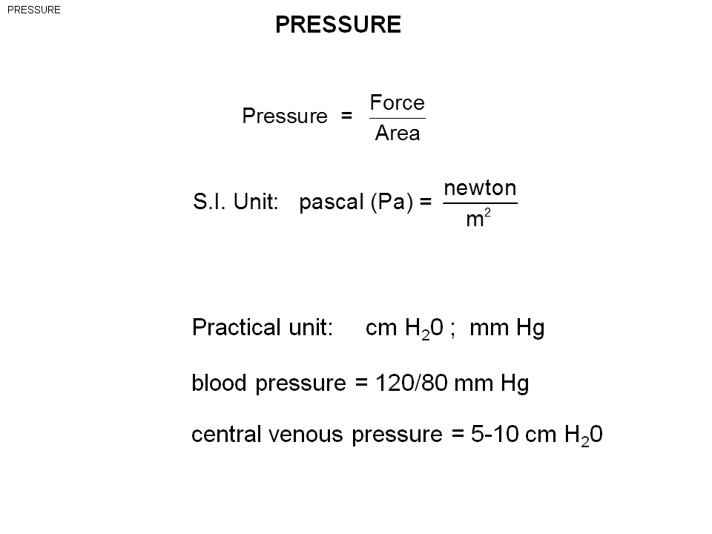

Force – newton. Area -m^2
Pa = Newton/Area
The practical unit use in phgy: cm H2O, mmHg
Blood pressure , on the arterial side the pressure is tend to be measure in mmHg.
On the venous side is tend to be recorded as cmH2O.
The central venous pressure =pressure in the veins

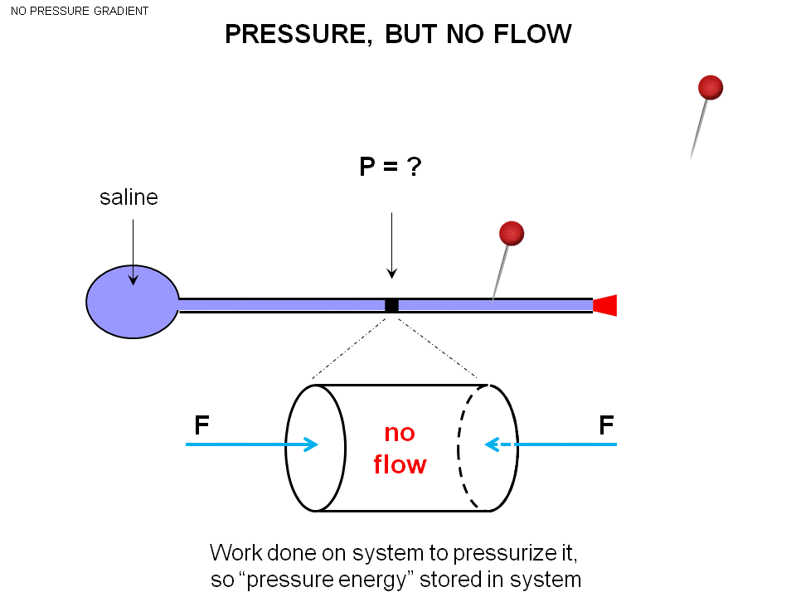
The bag is fill with saline with tube. You are able to squeeze the bag.
If want to create the pressure: stuck the end to prevent any flow, apply the force (pressure – squeeze) to the bag-> this pressure get transfer to the fluid, pressure apply the whole fluid in this entire system.
The system is now pressurized.
- We create a 10 cm H2O pressure, pressure will be 10cm everywhere.
- This is a static (no movement) system. (This means its not a dynamic system)
- 1) If we make a whole in the bag and squeeze at the same time The fluid will flow out in one direction .(Pressure is putting force in all directions.)

Take a small section, and look at the cylinder (white color) :
- The Force on the left: Pressure*Area acting in this direction pushing from left to right
- This is a static system.
- The force (pressure and cross area are the same) is the same on both side.
- No movement of fluid: static. (The fluid won’t move) The pressure is the same everywhere and there will be no movement. (Static)
When pressurize, apply the force to the whole system.
Apply a force to a distance ---doing Work!
- If do this to the bag long enough of time, it will fatigue.
- When pressurized the system, create a certain amount of work.
- The work is a form of energy, it goes into the pressure energy to the fluid.
- The energy you use to perform work , end up being pressure energy or a form of potential energy of the system.
If keep squeezing, and pin a hole => the fluid will come out (leak). However, the fluid won’t come out until it is empty. Why?
- As the fluid comes out , the pressure of the system is going down.
The energy is going to the kinetic energy of the flow to come up. This energy is from the pressurized system.
What happen when your left ventricle stop pumping?
- The arterial pressure drops
- The flow will drop
- You die
All the ventricle doing is to pressurized the artery, the energy is than get converted to the flow.
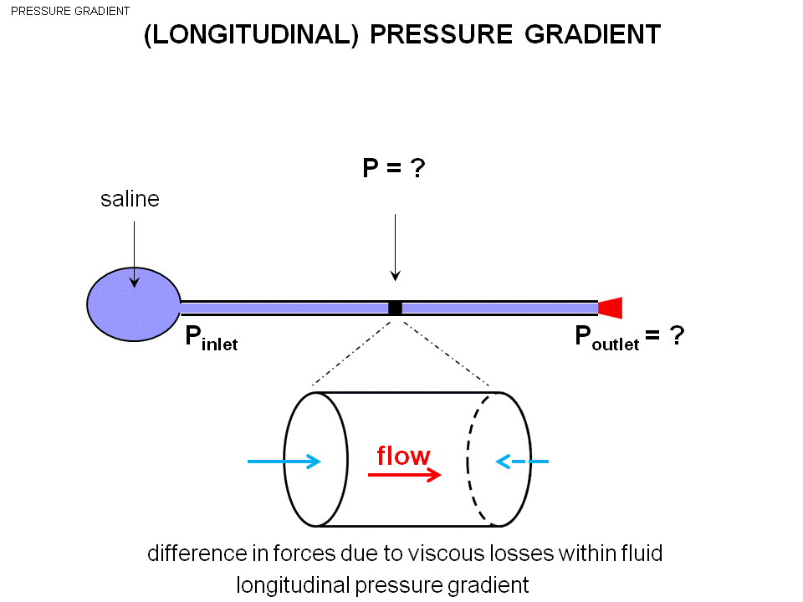
We want to get a flow.
Take the plug out -> have the flow.
Assume the pressure in the system is 20cmHg, outside is 0.
The pressure falls as move down the tube (20 19 1817…..The pressure is 10 when half way down the tube.)
If have a flow, you have a pressure gradient (spatial change in pressure ---the pressure is falling as you move along the distance.)
- Longitudinal pressure gradient (along the axis of the vessel in the direction of vessel.)
If the pressure of the right point is larger than the left with the same cross section area on both side, The force on the left will be higher than the right. The volume of the fluid will move to the left, If apply to the mass, will make it accelerate. But!!!This guy is moving in a constant velocity, not gonna accelerate.
- There must be a force in the opposite direction
- In fluid there is internal friction. As the fluid is moving along, the layers of fluid rub against each other and create friction. This friction create heat.
- As move down the tube, the pressure is falling, the pressure energy is falling. The energy is going out as heat.

